Draw the Path — Portfolio Sitemap + Toolkit
General AI Fluency Track · Week 1 · Setup

Proof statement
I turn messy, real-world data into reliable machine learning models that solve business problems — from cleaning and feature engineering through training, evaluation, and clear communication of results. I'm proving this to a hiring manager at a small or mid-sized company looking for an entry-level Data Scientist or ML Engineer who can own the full workflow independently, so they'll reach out to set up a conversation.

One-line why
A CV lists tools and a bootcamp certificate; it can't show I can independently carry a messy dataset all the way to a model someone would trust — only seeing the actual work does that.

1. Sitemap
Landing / hero → Work / case studies → About → Contact. Four pages, each earning its place against the claim and the one action.
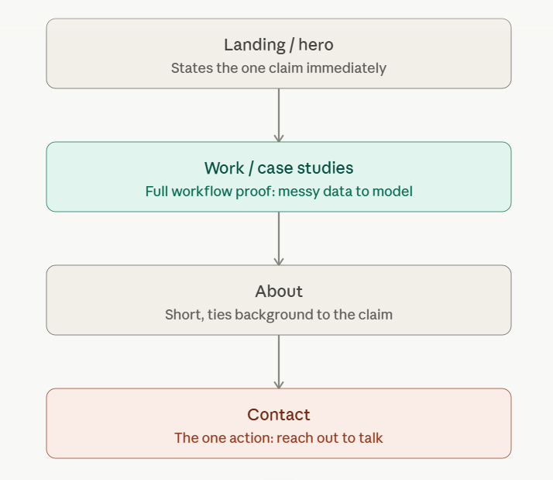
Sitemap sketch.

2. Claude Project
Project: “Portfolio sitemap and toolkit.” Custom instructions contain the proof statement above plus a tutor request, not defaults.
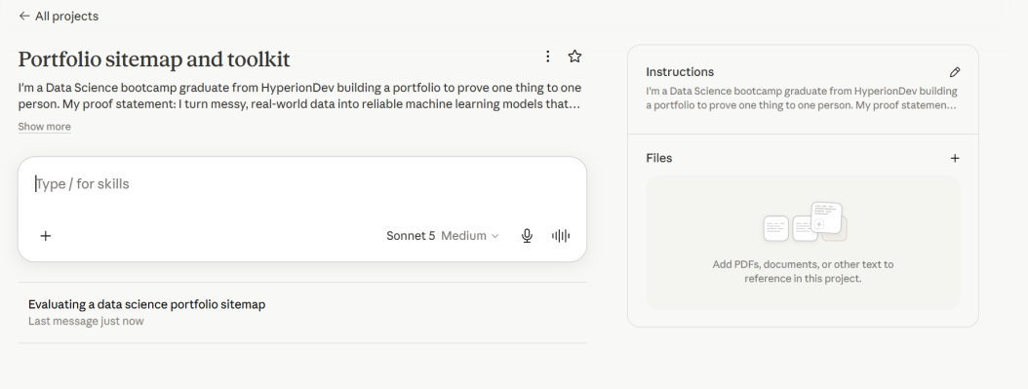
Configured Claude Project with genuine custom instructions.

3. Pressure-test: prompt
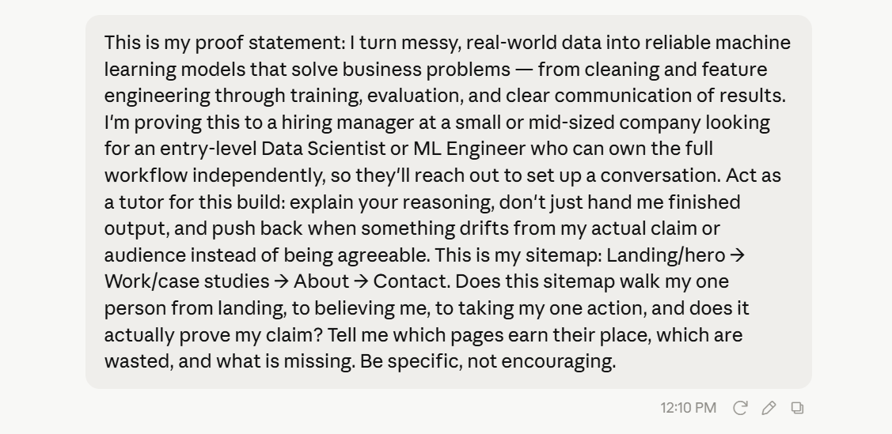
The pressure-test prompt sent inside the project.

4. Pressure-test: output
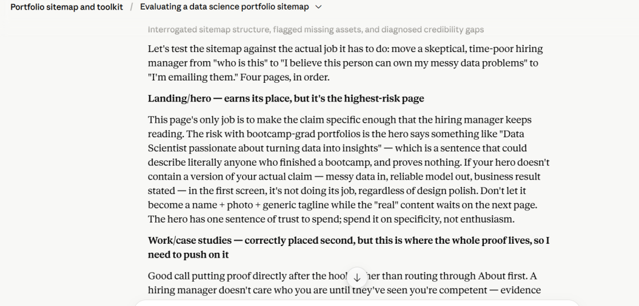
Claude's critique of the sitemap against the claim and one action.

5. What I'm changing
Claude flagged that the hero page is the highest-risk page in the sitemap: if it opens with something generic like “Data Scientist passionate about data,” it proves nothing and could describe anyone who finished a bootcamp. I'm rewriting my hero to open with a version of the actual claim — messy data in, reliable model out, business result stated — instead of a generic tagline, so the one sentence of trust I get on that page is spent on specificity, not enthusiasm.

